CS10310: Solutions to Worksheet 1
- A = {a,b,c}. |A| = 3; |P A| = 8
- B = {{a,b,c}}. |B| = 1; |P B| = 2
- {a,b} × {a,b,c,d} = {(a,a),(a,b),(a,c),(a,d),(b,a),(b,b),(b,c),(b,d)}
- U = {0,1,2,3,4,5,6,7,8,9}. A = {x|x∈U & x ≥ 3}. B = {x|x∈U & x ≤ 4}
  - A ∩ B
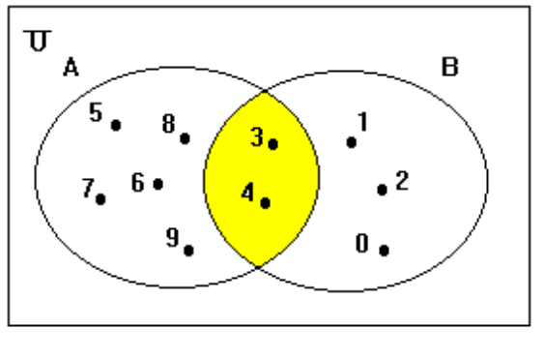
  - A ∪ B
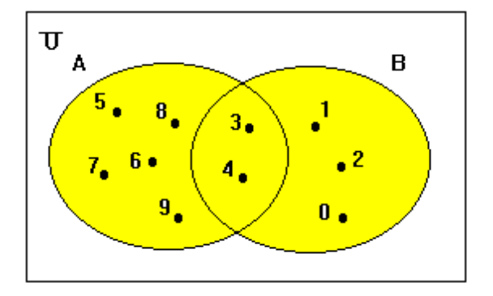
  - A - B
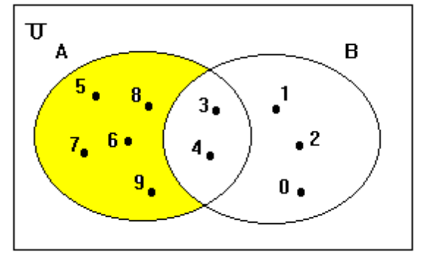
  - B - (A - B)
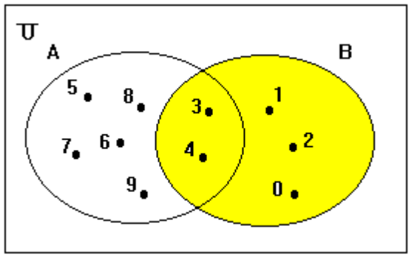
  - ~A
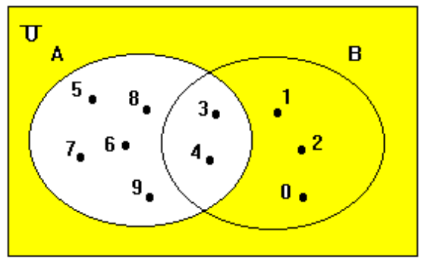
  - ~~A
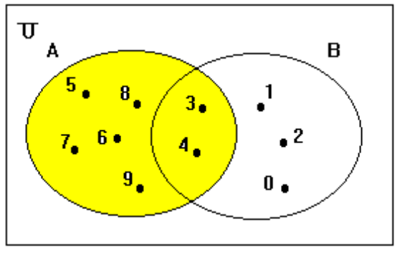
  - A ∩ ~A
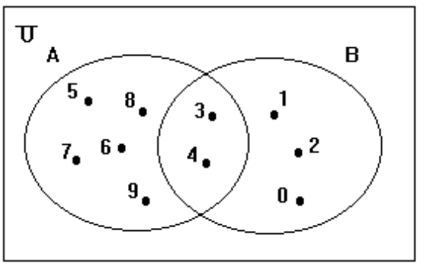
  - A ∪ ~A
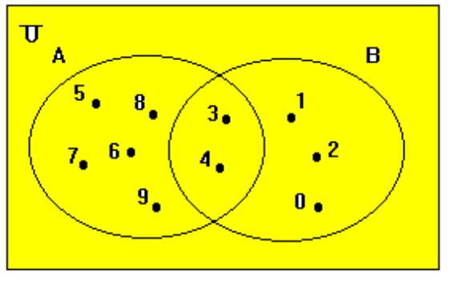
- Cats = {x | x is a cat}; Dogs = {x | x is a dog}.
  - Cats ∩ Dogs = {x| x is a cat and x is a dog}
  - Cats ∪ Dogs = {x| x is a cat or x is a dog}
- A = {a,b,c}; B = {b,d}; C = {a,c,e}.
  - (A ∩ B) ∩ C = ∅
  - A ∩ (B ∩ C) = ∅
  - (A ∪ B) ∪ C = {a,b,c,d,e}
  - A ∪ (B ∪ C) = {a,b,c,d,e}
  - A ∪ (B ∩ C) = {a,b,c}
  - A ∩ (B ∪ C) = {a,b,c}
- (a) ~(A ∪ B) = ~A ∩ ~B
~(A ∪ B)
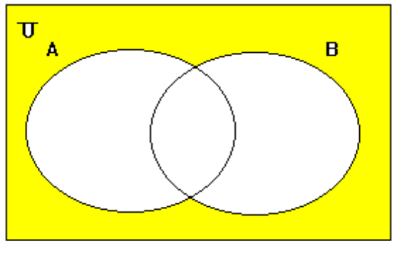
- ~A
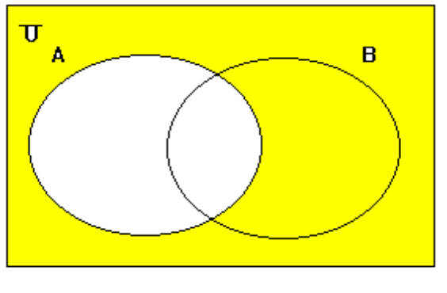
~B
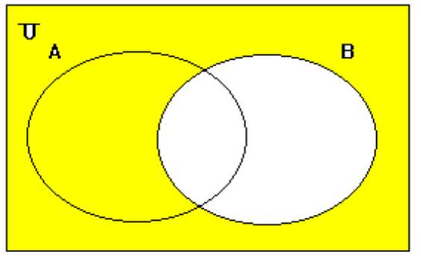
~A ∩ ~B = ~(A ∪ B)
Given (a) ~(A ∪ B) = ~A ∩ ~B and the fact that ~~A = A
deduce (b) ~( A ∩ B) = ~A ∪ ~B
Proof: ~(A ∪ B) = ~A ∩ ~B, from (a) above
~(~A ∪ ~B) = ~~A ∩ ~~B = A ∩ B, substituting ~A for A and ~B for B in (a)
~(~A ∪ ~B) = ~~A ∩ ~~B = A ∩ B, since ~~A = A
~~(~A ∪ ~B) = ~(A ∩ B), negating both sides of the equation
~A ∪ ~B = ~(A ∩ B), since ~~A = A
- Russell’s paradox: let S = {X | X ∉ X}; is S ∈ S?
If we answer ‘yes’, then S ∈ S, so S ∉ {X | X ∉ X}, so S ∉ S.
If we answer ‘no’, then S ∉ S, so S ∈ {X | X ∉ X}, so S ∈ S.

